Sally Mukami

[Sally.mukami@womentechsters.org](mailto:Sally.mukami@womentechsters.org)

Practical Activity 4

Solution

1. I started by creating a bash script file called password.sh

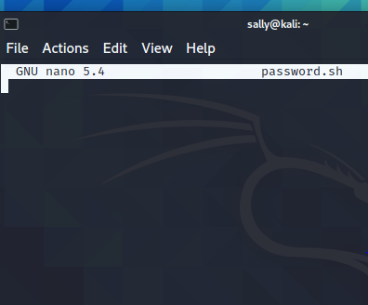

1. I made the bash script executable using the command “chmod +x password.sh”

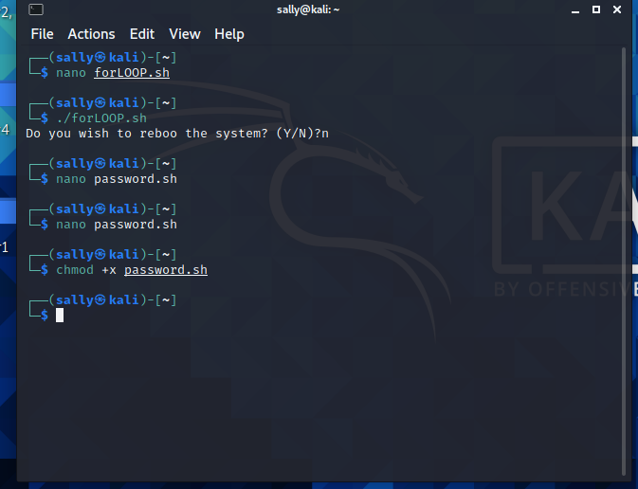

1. I created the password.sh file before reading the instruction on the practical activity document so I later renamed the password.sh to authentic.sh

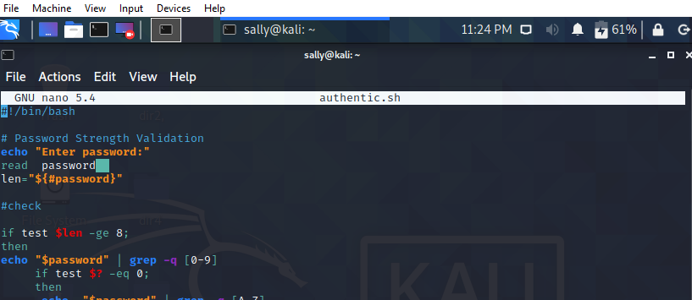

1. The code I used is nested if else statement and the grep command to check if the password included numbers, capital letters and numbers.

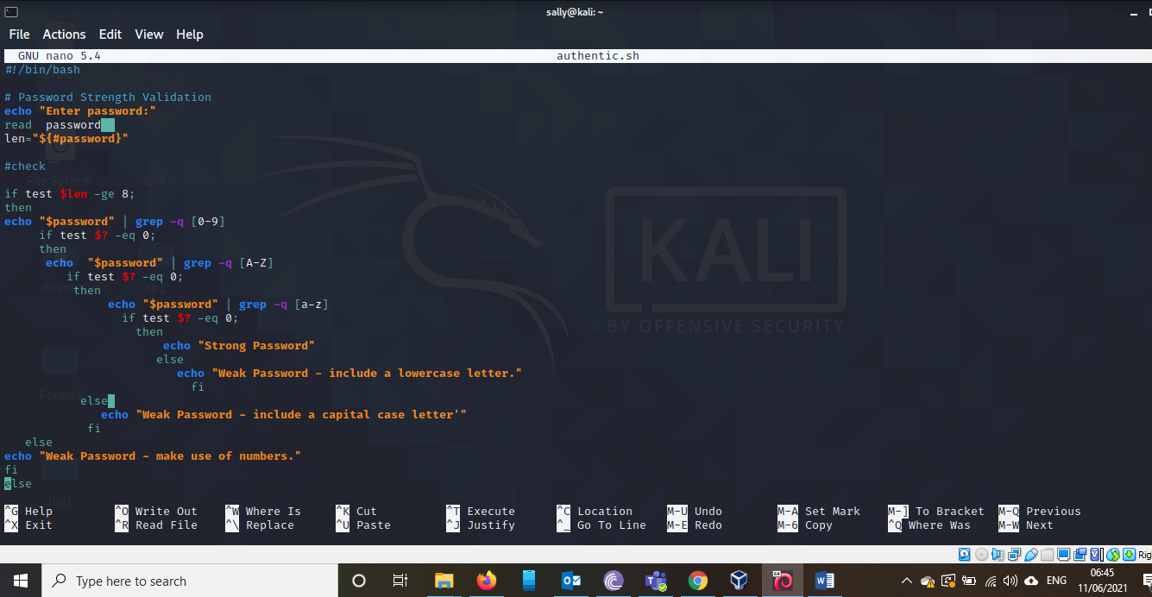

1. The different password trials I conducted and the response I got

